1.Blockchain-based Validation

🔗 Core Idea (Blockchain Validation)
A blockchain is a distributed ledger that stores data in blocks, making it immutable (cannot be changed once written).
Here, instead of storing the entire certificate, we only store its digital fingerprint (hash) on blockchain.
That way:
- File stays private (kept in DB/DigiLocker).
- Blockchain proves that the file hasn’t been changed since issuance.

🛠 Process Flow
1. Institution Issues a Certificate
- A student’s marksheet or degree (PDF) is issued.
- Compute its hash (SHA256).
- 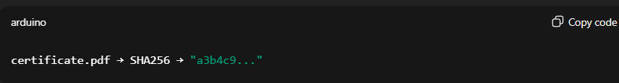 Convert certificate data into a structured JSON:
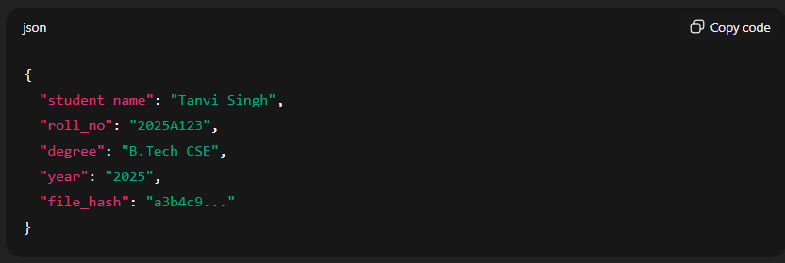
2. Store Hash on Blockchain
- Only the file hash (and metadata like student ID, institution ID, timestamp) is pushed onto blockchain.
- Once written, nobody can modify or delete it.
👉 If blockchain = Hyperledger Fabric:
- Write a chaincode (smart contract) that:
  - Accepts certificate_id + hash.
  - Stores it in ledger with timestamp.
👉 If blockchain = Ethereum private chain:
- Write a Solidity smart contract with a mapping:
  - 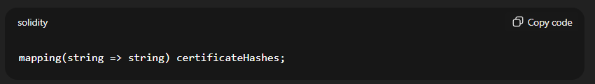 Store certificate hash against student ID.
👉 If certificate files are huge:
- Store the PDF in IPFS (InterPlanetary File System) → get unique content hash (CID).
- Store only the CID on blockchain.

3. QR Code for Access
- QR code contains certificate ID + blockchain transaction ID.
- When scanned, system fetches the stored hash from blockchain.

4. Verification
When a recruiter/university verifies:
- Take the certificate file (or QR code).
- Compute its hash again.
- Fetch the stored hash from blockchain (using certificate ID).
- Compare:
  - If same → ✅ certificate is authentic.
  - If different → ❌ certificate is tampered.

⚙️ Tools to Use
🔹 Blockchain
- Hyperledger Fabric (best for hackathon, permissioned = only universities, UGC, etc. can participate).
- Ethereum Private Network (easier with Solidity contracts).
🔹 File Storage
- IPFS → if you want decentralized document storage.
- Or just store PDFs in PostgreSQL/DigiLocker and keep only hashes on blockchain.
🔹 Integration
- Use Fabric SDK (Python/Node.js) or Web3.py (Ethereum) from your backend.
- API endpoints will call blockchain functions to store or verify.

✅ Benefits
- Immutable record → once certificate is issued, it cannot be altered or faked.
- Decentralized trust → no need to call the issuing college, blockchain itself is proof.
- Instant verification → recruiter just scans QR, system checks against blockchain.

